01076254 Object-Oriented Analysis and Design
Homework #1 Use Case Diagrams

- Creating a use case diagram

From the Enterprise architect "Project Browser" window, right-click on the Restaurant package. Select “Add -> Add Diagrams...” then choose "UML Behavioral->Use Case" on "New Diagram" window. After creating a use case diagram, you can right-click on it and select “Properties...” to change the diagram features such as name, description, and properties. To start adding components into the use case diagram, if the drawing toolbar is not already shown, open the drawing toolbar by press "Alt+5". You can select a component, from the diagram tools in the drawing toolbar, to add into the use case diagram. You can right-click on a component in the diagram and then select “Appearance...” from the menu if you want to customize the component appearance and select “Properties...” to add to it any further detail description.

- Draw the following use case diagram:

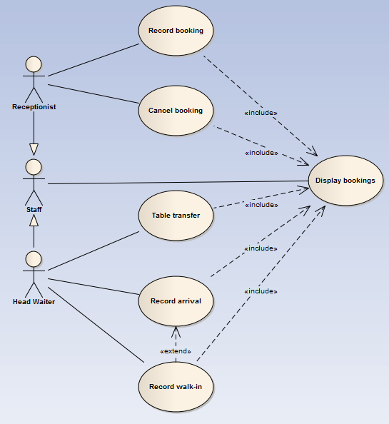
Figure 1: A Use Case Diagram of the Restaurant System

Case Study 2: Appointment System

The system to be developed is an appointment system for a doctor’s office. The system supports management of patients’ information and their appointments. Patients can request for a new appointment at the available time slot. They can also change or cancel their appointment later.

Figure 2 shows an activity diagram that represents part of an appointment system. The diagram represents the business process being developed. It also documents requirements of the system.
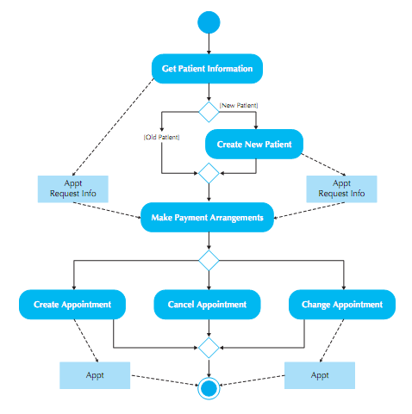
Figure 2: Activity Diagram for an Appointment System

After doing a business modeling, you should be able to extract enough information to derive a use case description and a use case diagram from a business model. Figure 3 shows a sample use case description for the “Make Appointment” use case.

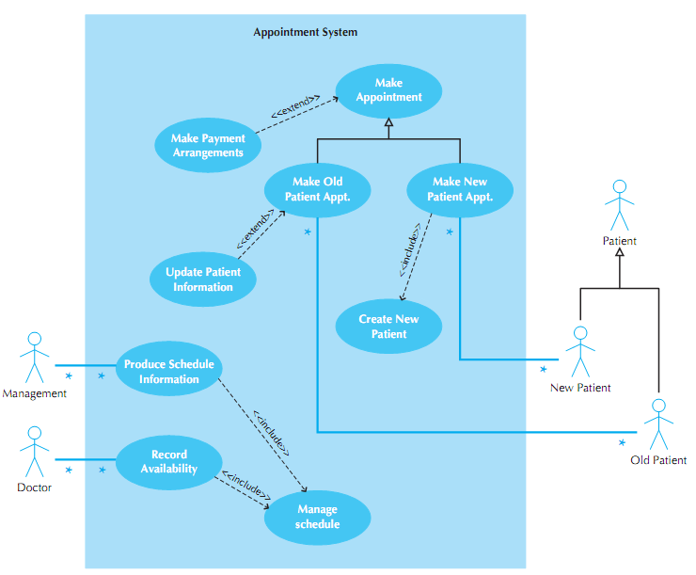
Figure 3: Sample use case diagram for the appointment system

Exercises
1. Create a project in Enterprise Architect for the restaurant system (case study 1). After that create the use case diagram for the Restaurant system. For each use case you must also add a use case description to address its basic courses of events, alternative courses of events, and exceptional courses of events.

2. Create a project in Enterprise Architect for the appointment system (case study 2). After that create use case diagram as shown Figure 3. For each use case you must also add a use case description to address its basic courses of events, alternative courses of events, and exceptional courses of events.

